K.V.G. DENTAL COLLEGE & HOSPITAL
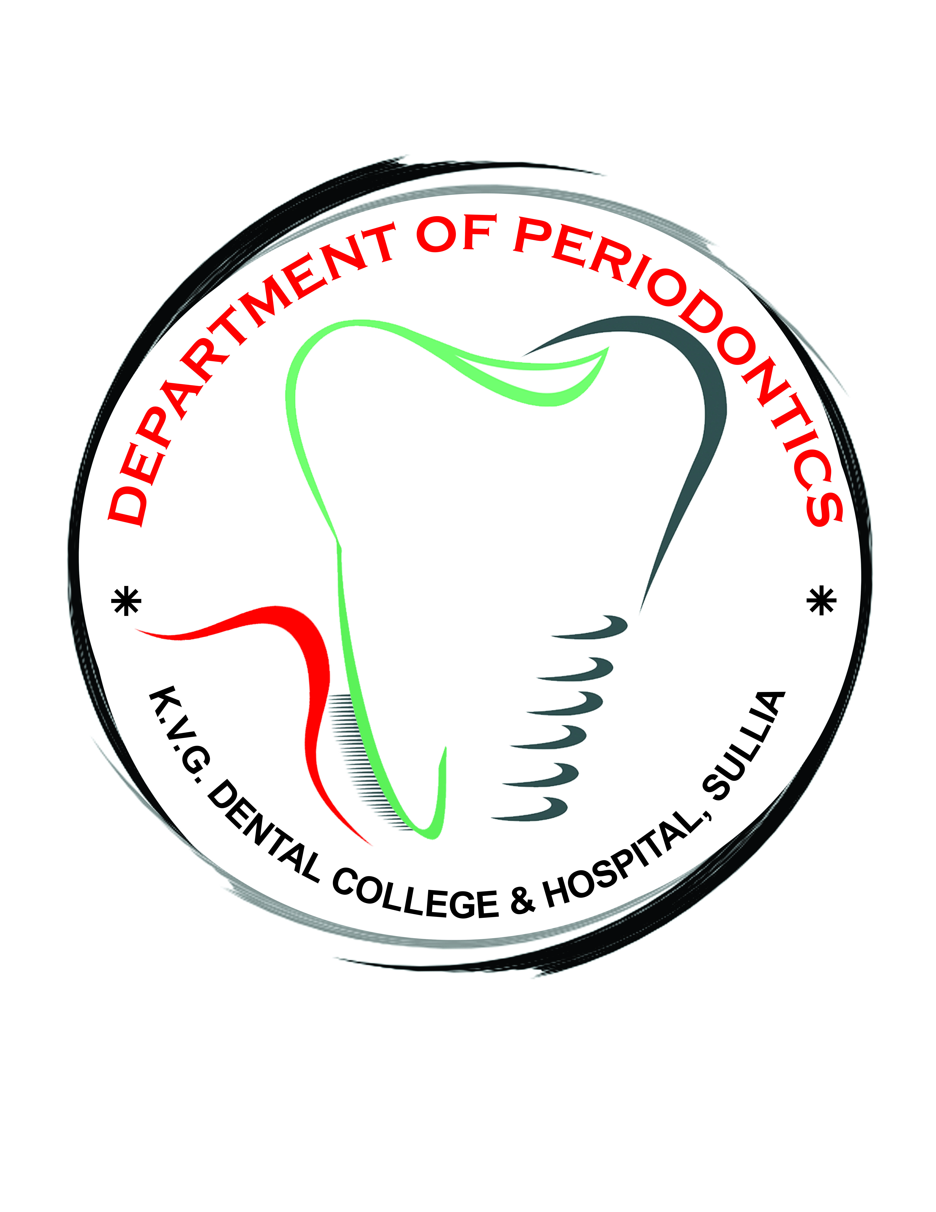
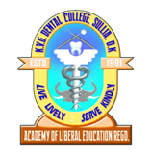
KURUNJIBAG – 574 327, SULLIA, Dakshina Kannada [Karnataka ] India
SPONSORED BY ACADEMY OF LIBERAL EDUCATION (REGD.) SULLIA
Recognized by DCI, New Delhi & Affiliated to RGUHS, Karnataka
Phone: 08257-235148/230148 Website:www.kvgdentalcollege.com

DEPARTMENT OF PERIODONTOLOGY

07/06/2021

INTERNS TRAINING PROGRAMME

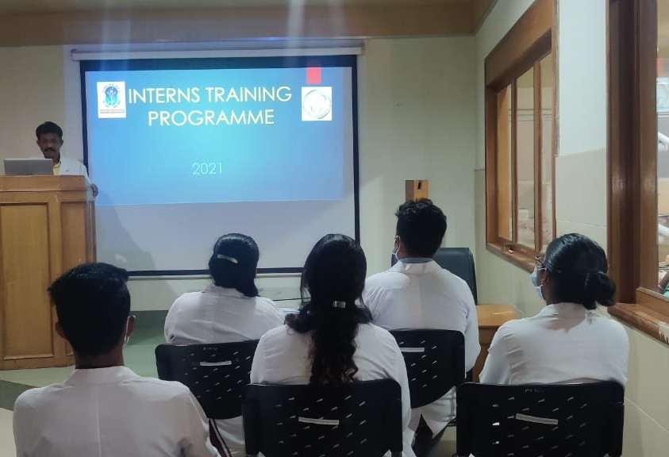
Lectureby Dr. M MDayakar, Professor and Head, Department of Periodontology

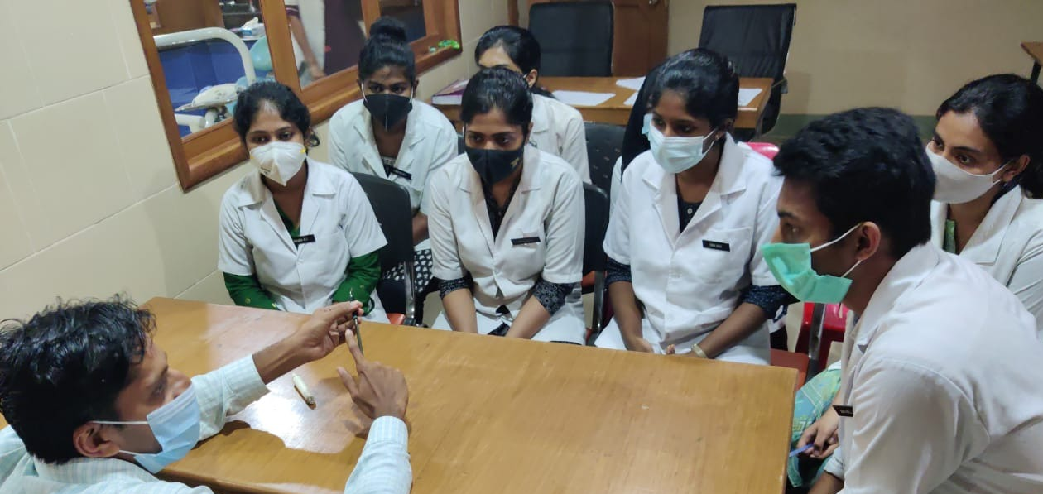
Demonstrartion given by Dr.Shivanand.H, Professor, Department of Periodontology

